Labs instruction. Week 1

R is a programming language widely used for data analysis. The first problem set, we will use the library

- dplyr: for cleaning and data transformation

- ggplot2: for data vizualization

We can load this libraries usingcommand install.packages. Create new file (File -> New File -> RScript) and copy rows:
install.packages("dplyr") install.packages("ggplot2")
Press Run button with green arroe or using key combination CTRL + ENTER or COMMAND + ENTER.

Then download those libraries to your working environment. This can be done with using the library. Note that we set the library once, but you need to download it every time you restart RStudio. That is the next time RStudio installation team will not be necessary and they will be using the # comment out:
#install.packages("dplyr")

#install.packages("ggplot2")
Add rows:
library(dplyr)

library(ggplot2)

Data import

Download file "flats.csv" and save in folder with RScript. Load data from file "flats.csv" in flats variable using function read.csv.
flats <- read.csv("flats.csv", stringsAsFactors=FALSE)

Parametr stringsAsFactors = FALSE means, that variables that are of type character will not be converted to data type factor. This type is used to work with categorical variables, but within this laboratory we will not use it.

If you have error

Error in file(file, "rt") : cannot open the connection In addition: Warning message: In file(file, "rt") : cannot open file 'flats.csv': No such file or directory

specify the path to that directory using command setwd (short set working directory). This command allows not specify the full path to that directory.
setwd("file path")

# example:
#setwd("~/work/stats_course/materials/week2")
Define Properties class flats with the command class()
class(flats)

## [1] "data.frame"
Class flats data.frame object or table data. Each row of this table represents an observation, and each column displays a variable that is part of the information about this observation. You can use function str (short for structure) to quickly assess whether your boot data.
str(flats)

## 'data.frame': |  |  | 839 obs. of |  | 4 | variables:
## | $ | City | : chr | "Lviv" |  |  | " Lviv " " Lviv " |  | " Lviv " ...
## | $ | Rooms | : int | 3 3 2 | 2 | 3 | 1 3 3 | 1 6 ...
## | $ | Square: num |  | "120" | "66" "66" |  |  | "44" ...
## | $ | Price | : num | 1875000 |  | 975000 1375000 637500 |  |  | 835000 ...
We see that Square variable has type "character", that was recognized as a text variable. See the documentation for read.csv functions using function ?
?read.csv
We see that as the decimal separator used by default point dec = '.'. In our data, decimal separator is a comma.

Re-reads the data specifying the decimal separator option:
flats <- read.csv ( "flats.csv", stringsAsFactors = FALSE, dec = ",")
Check them structure:
str(flats)

## 'data.frame': |  |  | 839 obs. of |  | 4 | variables:
## | $ | City | : chr | " Lviv " |  |  | " Lviv " " Lviv " |  | " Lviv " ...
## | $ | Rooms | : int | 3 3 | 2 2 | 3 | 1 3 3 | 1 6 ...
## | $ | Square: num |  | 120 | 66 66 |  | 44 63 | 31 46 64 35 200 ...
## | $ | Price | : num | 1875000 |  | 975000 1375000 637500 |  |  | 835000 ...

Data analisys
• To find the number of measurements used function dim ()
• head () displays the first part of the object, the first parameter is the object (table data flats here, the second parameter can specify the number of rows)
• tail () reflects the last part of the object can also specify the number of rows
• names () names associated with the object
Exercises
• Find the number of measurement in flats dataframe.
• Display the first six rows, the first fifteen lines, last six strings.
• Display names of dataframe.

Data transformation
In R you can use the str () and summary () to get first knowledge of table. The library dplyr has a function glimpse () for the rapid synthesis table.

# Look at structure |  |  |  | of flats
str(flats)
## 'data.frame': |  |  |  | 839 obs. of 4 variables:
## | $ City |  |  | : chr | " Lviv " |  | " Lviv " " Lviv " " Lviv " ...
## | $ Rooms |  |  | : int | 3 3 2 2 3 |  | 1 3 3 1 6 ...
## | $ Square: num |  |  |  | 120 66 66 |  | 44 63 31 | 46 64 35 200 ...
## | $ Price |  |  | : num | 1875000 975000 1375000 637500 835000 ...
# View a summary of |  |  |  | flats
summary(flats)
## | City |  |  |  | Rooms |  | Square |  | Price
## | Length:839 |  |  | Min. |  | :1.000 | Min. | : 14.00 | Min. | : | 10200
## | Class | :character |  | 1st Qu.:1.000 |  |  | 1st Qu.: 43.75 |  | 1st Qu.: |  | 537500
## | Mode | :character |  | Median |  | :2.000 | Median | : 56.00 | Median | : | 775000
## |  |  |  | Mean |  | :2.045 | Mean | : 64.07 | Mean | : 1042710
## |  |  |  | 3rd Qu.:3.000 |  |  | 3rd Qu.: 75.00 |  | 3rd Qu.: 1200000
## |  |  |  | Max. |  | :6.000 | Max. | :222.60 | Max. | :12250000
# Get a glimpse of flats
glimpse(flats)
## Observations: 839
## Variables: 4
## $ City |  |  |  | <chr> | " Lviv ", |  | " Lviv ", " Lviv ", " Lviv ", "Lv...
## $ Rooms |  |  |  | <int> | 3, 3, 2, 2, 3, 1, 3, 3, 1, 6, 2, 1, 1, 2, 3, 3,...
## $ Square |  |  |  | <dbl> | 120.00, 66.00, 66.00, 44.00, 63.00, 31.00, 46.0...
## $ Price |  |  |  | <dbl> | 1875000, 975000, 1375000, 637500, 835000, 56250...
We learn that the number of apartments sold in each city (according to this data set):
The library dplyr for that function count:
count(flats, City)

## # A tibble: 13 × 2
## | City | n
## | <chr> <int>
## 1 | Lviv | 275
## 2 |  | 18
## 3 |  | 13
## 4 |  | 47
## 5 |  | 19
## 6 |  | 186

## 7 |  | 16
## 8 |  | 15
## 9 |  | 43
## 10 |  | 23
## 11 |  | 93
## 12 |  | 14
## 13 |  | 77
Exercise
Find count of flats by square
If we want to consistently perform several operations dplyr operator can use%>%, which allows you to use the following command to the current results. For example, sort out the details of the number of apartments in each city in ascending order:
flats %>% count(City) %>% arrange(n)
## # A tibble: 13 × 2
## | City | n
## | <chr> <int>
## 1
## 2
## 3
## 4
## 5
## 6
## 7
## 8
## 9
## 10
## 11
## 12 |  | 186
## 13 |  | 275

Remove this data from the display using the command filter. Let me remind you that the condition is referred to as ==, not equals as! =. There Sort results in descending by selecting arrange (desc (n)).
flats %>%

filter(City | != "Lviv") %>%
filter(Rooms == |  | 3) %>%
count(City) | %>%
arrange(desc(n)) |  | # arrange - sorting, desc - descending order
## # A tibble: | 12 × 2
##
##
## 1

## 2 |  | 50
## 3 |  | 24
## 4 |  | 22
## 5 |  | 13
## 6 |  | 11
## 7 |  | 8
## 8 |  | 8
## 9 |  | 6
## 10 |  | 5
## 11 |  | 3
## 12 |  | 2

If we are interested in the number of two-bedroom apartments in each city, then choose only the number of apartments with 2 rooms:
flats %>%
filter(Rooms == 2) %>%
filter(City != "Lviv") %>% count(City) %>%
arrange(desc(n))

## # A tibble: 12 × 2
## | City | n
## | <chr> <int>
## 1 |  | 93
## 2 |  | 67
## 3 |  | 43
## 4 |  | 28
## 5 |  | 18
## 6 |  | 14
## 7 |  | 8
## 8 |  | 7
## 9 |  | 7
## 10 |  | 5
## 11 |  | 5
## 12 |  | 2

Summarise function allows you to summarize data. For example, to find the average value of apartments in the area of each region. For calculating the mean use function mean.
flats %>%
filter(Rooms == 2) %>%
filter(City != " Kiev Svyatoshinsky ") %>% summarise(mean(Total area))
- mean(Total area)
## 1 | 60.81832
You can calculate not only the area, but the standard deviation of using sd:
flats %>%
filter(Rooms == 2) %>%
filter(City! = "Kharkiv") %>% summarise(mean(Square), sd(Square))

- mean(Square) sd(Square)
## 1 | 60.81832 | 16.61458
You can specify column names, such as mean = mean (Square):
flats %>%
filter(Rooms == 1) %>%
filter(City!= ""Kharkiv") %>% group_by(City) %>%
summarise(mean=median(Square), sd=sd(Square))

## # A tibble: 12 × 3

## | City | mean | sd
## | <chr> <dbl> |  | <dbl>
## 1 |  | 40.0 | 7.665871
## 2 |  | 32.0 | NA
## 3 |  | 36.4 | 9.050967
## 4
## 5 |  | 39.0 | 8.015938
## 6 |  | 43.0 | 6.269465
## 7 |  | 37.5 | 6.363961
## 8 |  | 39.0 | 5.015531
## 9 |  | 35.0 13.086362
## 10 |  | 43.0 | 8.079379
Exercises

• How many variables in a dataset flats?
• How many cities in the dataset flats?
• How many three-bedroom apartments for sale in Odessa?
• What is the median area one-room apartment in Lviv?

• Find dispersion of Price for all flats in Lviv with 2 rooms (use function var in summarise)

Data Visualization:

For data visualization library will use ggplot2. During the exploratory data analysis (Exploratory Data Analysis) cleaning processes and data visualization is cyclical (as you have seen in the video lectures). For charting function is used ggplot () after the code you see in the graph Plots tab in the lower right pane in RStudio.
• The first argument is that function data set (dataset)
• Next, we specify variables from the data set as a parameter aesthetic, that will be shown, for example, the x and y
• The next step we add another level (combining them with +) to set the geometric object. For example, to schedule a scattering geom_point for geom_line line graph, bar chart for geom_bar
Construct a bar chart for the number of rooms:
ggplot(flats, aes(x=Room)) +

geom_bar(fill="lightblue",
col="grey") +
ylab(' Number ')

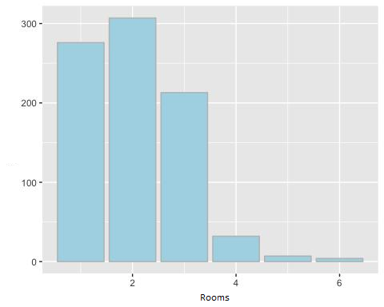

Construct a bar chart for variable Total area:

Column chart

p <- ggplot(flats, aes(x= Square)) + geom_bar(fill="lightblue",col="grey") + ylab(' Number ')
p

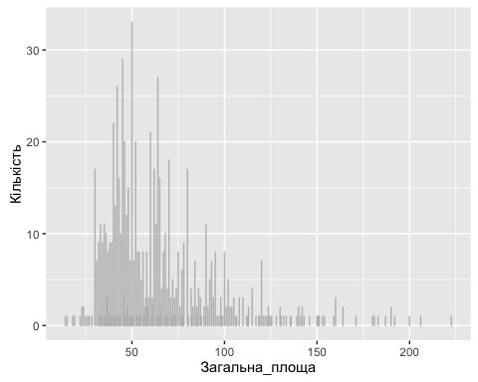

Histogram

Used to assess quantitative variable forms of distribution. In this chart the distribution of apartments that sold for a total area.

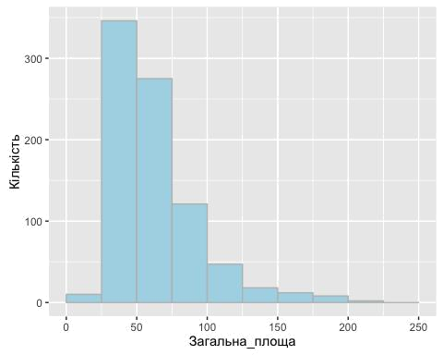

Depending on the size of the interval it can change form. Such as changes range from 25 square meters to 50:
ggplot(flats, aes(x=Square)) +
geom_histogram(breaks=seq(0, 250, by = 50),
fill="lightblue",

col="grey") +ylab('Number')
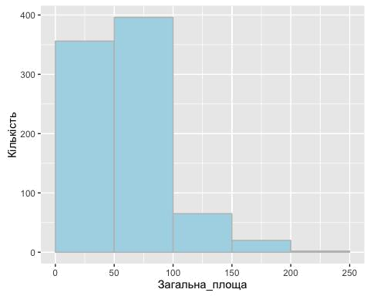

Figure scattering. Construct a graph of the price of the total area.

library(ggplot2)
ggplot(flats, aes(x=Square, y= Price)) +
geom_point()
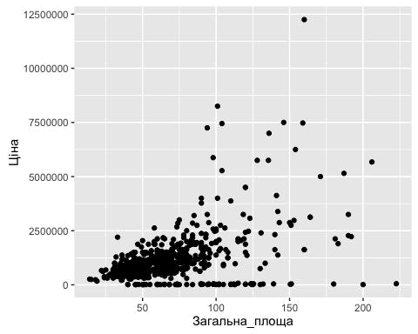

box chart

Compare the distribution of prices in cities and use the option coord_flip () to place a box diagram horizontally:
Useful functions:
ggplot(flats, aes(x=Square, y= Price)) + geom_boxplot() + coord_flip()

scale_x_reverse()

df <- data.frame(x = 1:5, y = (1:5) ^ 2)
ggplot(df, aes(x, y)) +
geom_area()

qplot(Room, Price, data=flats, geom="boxplot")

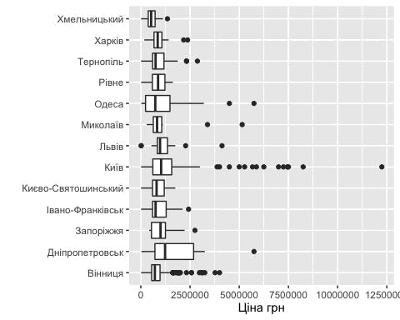

Exercises

- • Construct a box-like diagram for price visualization allocation based on the number of rooms
• Build scattering schedule that reflects the dependence of the price of the total area
• Construct a histogram for assessing price allocation of flats

